E.g: Meteorological data Daily precipitation totals, mean maximum afternoon temperatures and maximum vapor pressure deficits (VPDs) (mean of measurements between 900 and 1300 h) were obtained from a meteorological station
Vapour pressure deficit is calculated from the measurement of relative humidity and air
temperature from a meteorological station
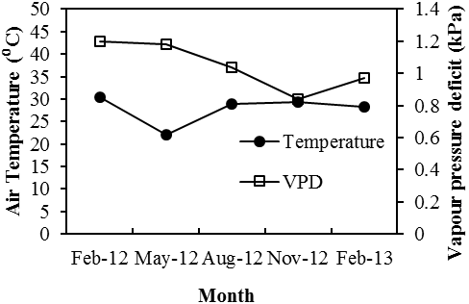
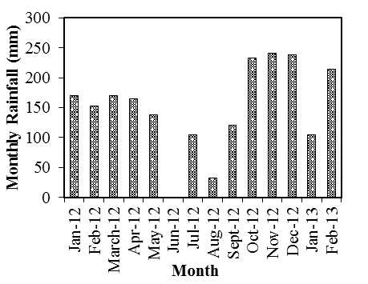
(b)
(a)

Potential Evapotranspiration

Potential evapotranspiration (PET; mm day-1) was calculated from measurements of net radiation, windspeed and atmospheric vapour pressure deficit using the standard Penman equation.

